Smart Parking Platform Project - $oftware ¢orp.
Homework 3
Gerardo Vera
CIS 4374
September 24, 2026

- Create Backlog
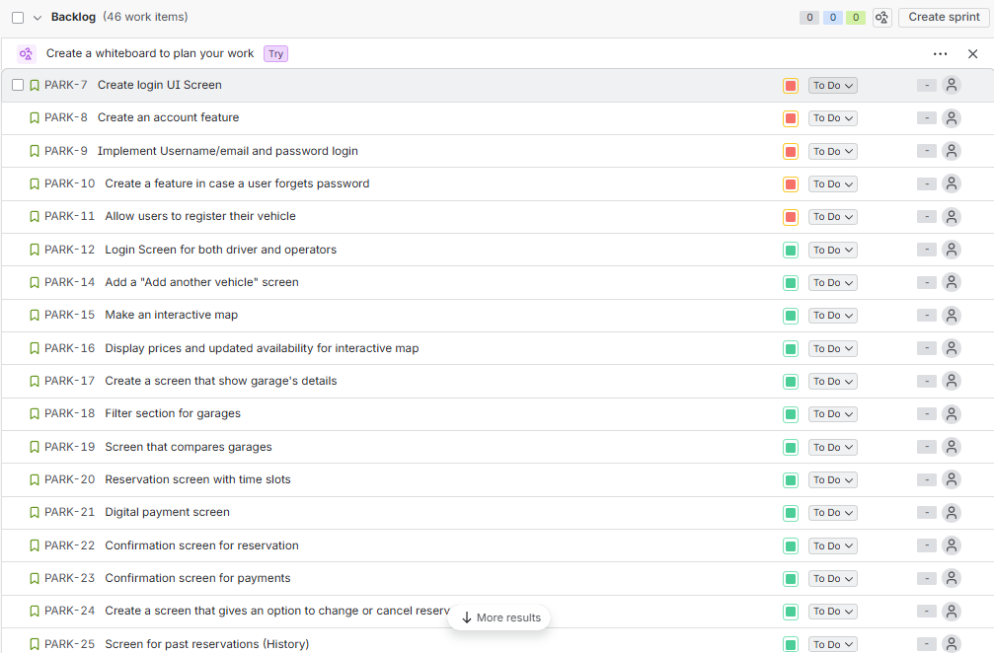
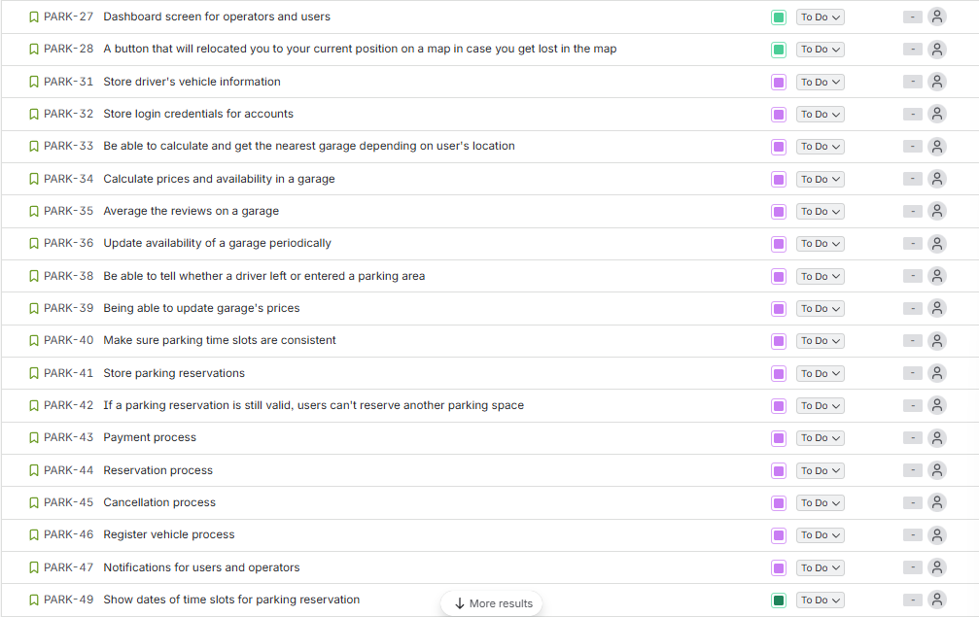
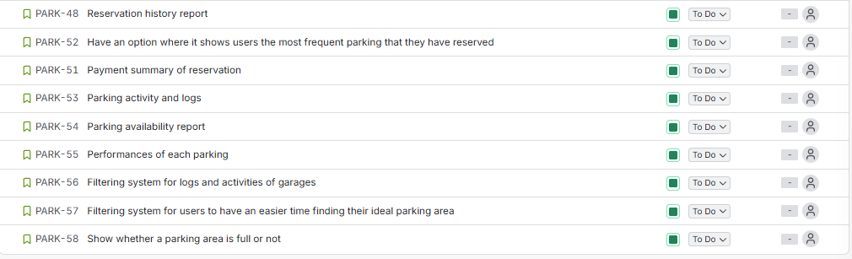
- Sprint 1 Backlog
